# THIRD WEEK CHALLENGE

# SHAOYUAN WANG

For this week I kept developing ideas. On Tuesday, I had Skype tutorial with Jon, he expended my thoughts. My idea was social dumbbells which encourage people do exercise together. But exercise can be different style, not just using dumbbells or other gym equipment, like doing housework, cycling, cooking and so on. So the exercise can be regarded as some movements which are possible to be low strength or high strength for people in different ages.

Sharing the movements with others is positive and interesting interaction for the members who have some distance from each other. I also talked with the friends who are into sports and activities. Most of them told me that they prefer to do sport with friends. And they are also curious about what activities are their friends doing.

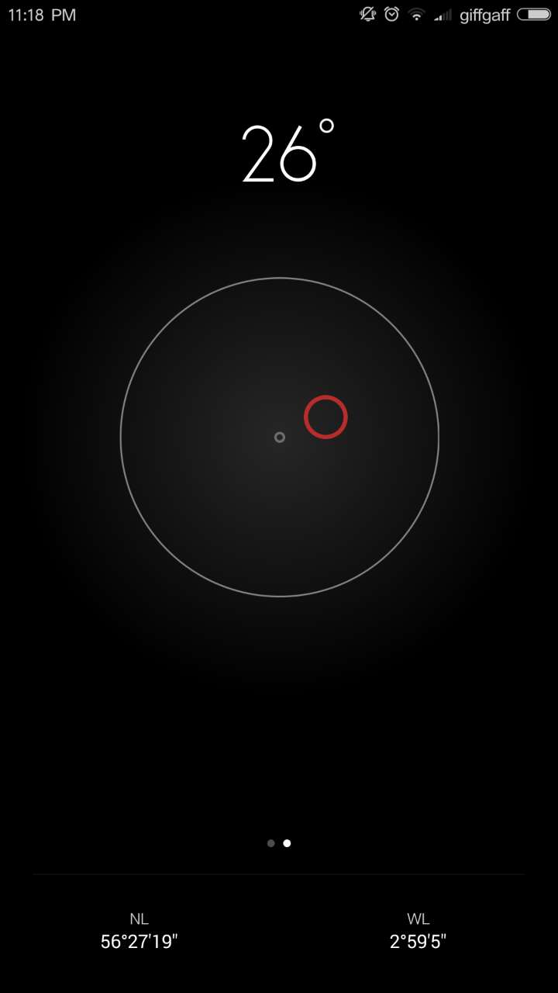That would be fun to know what movements your family members and friends are doing, even can be your pet like cat and dog. So I was thinking about sharing daily activities by visualizing behaviors. There were a few methods to visualize movements after my research. One of them is the function on the phone which tells the horizontal angle with moving circle.

However, considering about time wise, I chose tilt switches connected Arduino boards. But for sensitivity, I would like to find out better devices to support the concept in the future. Each LED lights will be connected with one tilt switch, then it works as the application on smart phone basically. It is designed as an portable attachment which can be attached on our body or animal’s or the products we are using. It is also available to carry in pocket to everywhere. The holders could be linked through internet so that people can monitor their partner’s activities. The product is possible to be in different use, for elderly and children, we can check safety; for pets, we can see how crazy they can be at home; for friends, it decrease their psychological distance.

I enjoyed the process when I develop my ideas. I can see how does my concept grow from the first one. And the story help me to think the problem and solution. I created various scenarios in different locations like home, park, office as well as with people in different positions or ages. The same product might occur different effects so it is playful to see people use it in different ways. Additionally, I expect my product to bring people together - Light Orchestra.

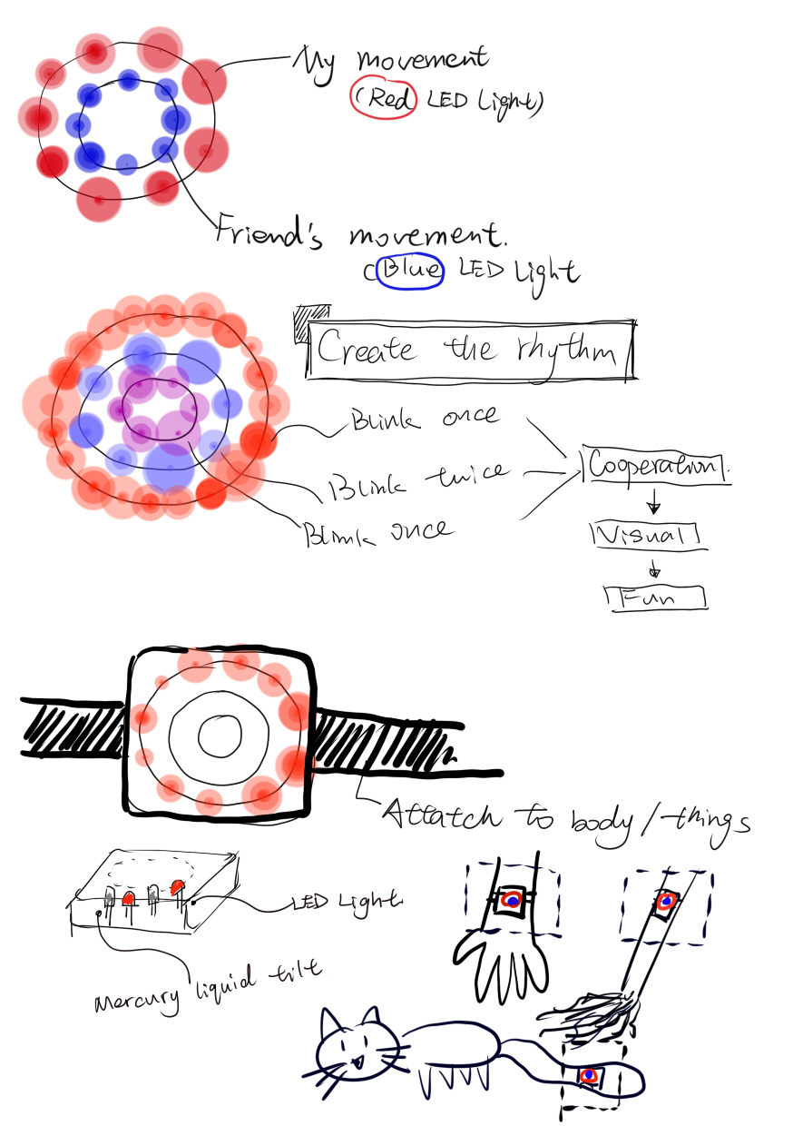

For the repetitive movements, it seems to make its own rhythm like drumming. I use the LED lights to present the behaviors. If members work at the same time, the light will blink simultaneously. After that, users can workout together to create their own light performance. I would like to say it is a movement game.

Next week, I should focus more on prototype to explain my concept. Material, structure, shape need to be concerned.